HOW TO CREATE DYNAMIC WEB PROJECT

Go to file 🡪 new🡪 select Dynamic web project

Give name to project

Change module version to 2.5

Next and finish

It will create folder

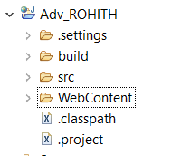

Now inside src create folder com

Inside com folder create one folder for servlets named any eg servlet

Eg: 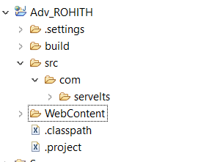

HOW TO CONFIGURE TOMCAT TO ECLIPSE: